37.46: a) The fraction of the initial mass that becomes energy is
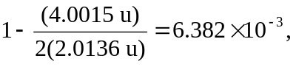and so the energy released per kilogram is
b) 